**Assignment - Week 1 Day 2**

**Submitted by:**

**23. Sunil Thapa(612810)**

**14. Anish Maharjan (613446)**

**5. Kapil Dangol (613417)**

**#) Question 1 :**

**=>**

**Algorithm 1:**

**Algorithm** GetThirdMax(arr):

**Input:** An array ‘arr’ of integers

**Output:** third maximum integer in an array

firstMax ← arr[0] 2

secondMax ← arr[0] 2

thirdMax ← arr[0] 2

n ← arr.length 2

for i ← 0 to n-1 do 1+n

if arr[i] > firstMax then 2(n-1)

firstMax ← arr[i] 2(n-1)

firstMaxInd ← I n-1

for i ← 0 to n-1 do 1+n

if ( i == firstMaxInd) then 2(n-1)

continue; 1

if ( arr[i] > secondMax) then 2(n-1)

secondMax ← arr[i] 2(n-1)

secondMaxInd ← I n-1

for i ← 0 to n-1 do 1+n

if ( i == firstMaxInd or i == secondMax) then 4(n-1)

continue; 1

if ( arr[i] > thirdMax) then 2(n-1)

thirdMax ← arr[i] 2(n-1)

return thirdMax 1

**Algorithm 2:**

**Algorithm** GetThirdMax(arr):

**Input:** An array ‘arr’ of integers

**Output:** third maximum integer in an array

max ← 0 1

preMax ← 0 1

prePreMax ← 0 1

n ← arr.length 2

for i ← 0 to arr.length do 1+n

if arr[i] >= max then 2(n-1)

prePreMax ← preMax n-1

preMax ← max n-1

max ← arr[i] 2(n-1)

else if arr[i] >= preMax then 2(n-1)

prePreMax ← preMax n-1

preMax ← a[i] 2(n-1)

else if a >= prePreMax then 2(n-1)

prePreMax ← a n-1

return prePreMax 1

**d) Graph :**

Testing array with size of [1000, 2000, 3000, 4000, 5000, 6000, 7000, 8000, 9000, 10000]

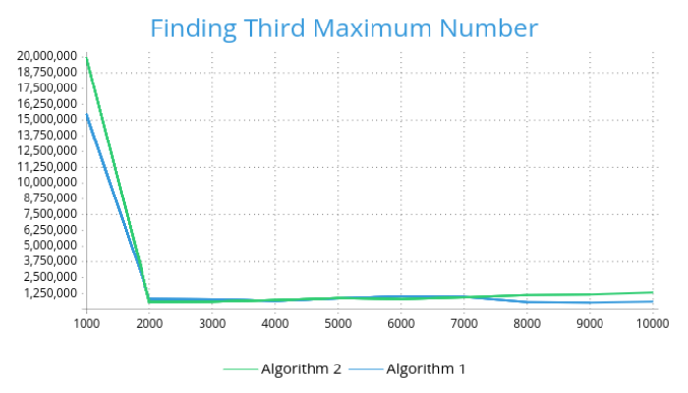

**#) Question 2 :**

